
Supporting: LMFKB3004A Conduct on-site adjustments to cabinets and components

Section 1 Assignment: Making adjustments
Name |  | Date

Question 1
Three different types of concealed hinge are shown below. Their names refer to the position of the door in relation to the side of the cabinet.
What is the name of each type of hinge?
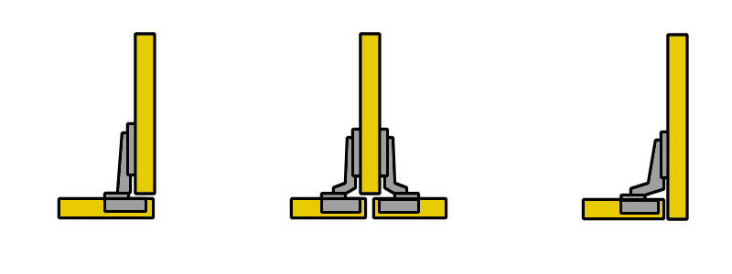

Question 2
Choose a concealed hinge that you commonly use in your cabinets and answer the following questions:
(a) Who is the manufacturer and what is the full name of the hinge?
(b) What is the standard gap that you try to achieve between doors?
(c) How do you fix a bind in the door with this type of hinge?

Question 3
Choose a drawer system that you commonly use and answer the following questions:
- How is the drawer front fixed to the drawer? If it uses a patented system, name the manufacturer and the product. If is a standard workshop-built drawer, describe the process for fixing the front.
- If a drawer front was high on one side in the finished cabinet, how would you drop that side so the front was level?

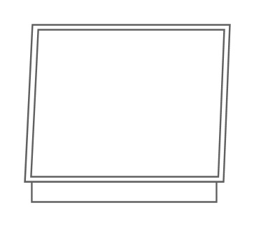
Question 4
The cabinet at right has been installed with a level top and base, but it has been pushed out of square because the wall is not plumb.
When the doors are hung, there will be a serious problem. Draw the two doors in position on the diagram to show what the problem will be.

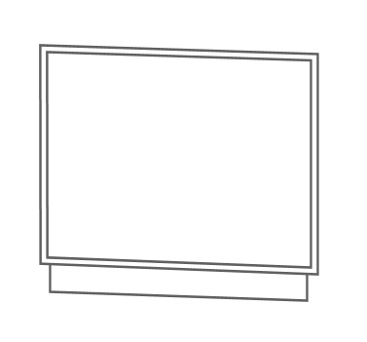
Question 5
This time the cabinet has been installed with plumb sides, but it has been pushed out of square because the floor isn’t level.
When the doors are hung, there will be a serious problem. Draw the two doors in position on the diagram to show what the problem will be.

(Note that the 'out of square' problems shown above have been exaggerated to illustrate the point. In practice the issue is not likely to be as pronounced, and in many cases may be almost invisible to the eye.)

